Ordinary Level Questions 2019

1.
The points P and Q lie on a straight level road.
A car passes P with a speed of 7 m s⁻¹ and accelerates uniformly, with acceleration a, for 3·5 seconds to a speed of 21 m s⁻¹.
It then travels at a constant speed of 21 m s⁻¹ for 9·5 seconds.
Finally, the car decelerates uniformly to a speed of 7 m s⁻¹ at Q.
The car travels 98 metres while decelerating.

Find
the acceleration, a
|PQ|, the distance from P to Q
the average speed of the car as it travels from P to Q.

A van travels from P to Q and takes the same amount of time as the car.
The van passes P with a speed of 7 m s⁻¹ and accelerates uniformly to a maximum speed of k m s⁻¹.
It then decelerates uniformly to a speed of 7 m s⁻¹ at Q.

Draw a speed-time graph of the motion of the van from P to Q.
Find the value of k.

2.
P is a point on the southern bank of a river.
Q is a point on the northern bank of the river, d km downstream from P.
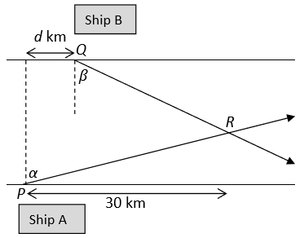
Ship A departs from P at a constant speed of 68 km h⁻¹ in the direction north 𝛼 east, where tan𝛼=

At the same time, ship B departs from Q at a constant speed of 58 km hr⁻¹ in the direction south 𝛽 east, where tan 𝛽 = .
Find
- the velocity of ship A in terms of 𝚤⃗ and 𝚥⃗
- the velocity of ship B in terms of 𝚤 ⃗and 𝚥⃗
- the velocity of A relative to B in terms of 𝚤⃗ and 𝚥⃗.

The paths of A and B intersect at point R, which is 30 km downstream from P.

Find
- the time it takes ship A to reach point R
- the value of d if ship B reaches point R twelve minutes after ship A
- the width of the river, assuming its banks are parallel.

3.
A particle is projected from point P, as shown in the diagram, with initial speed 82 m s⁻¹ at an angle of α to the horizontal, where tan 𝛼 = .
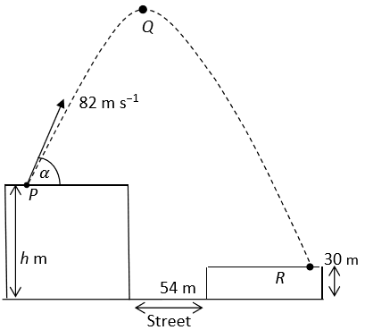
P is a point on the horizontal roof of a tall building of height h m.
Q is the highest point reached by the particle.
The particle lands at R, a point on the horizontal roof of another building of height 30 m, as shown.

Find
- the initial velocity of the particle in terms of 𝚤 ⃗ and 𝚥 ⃗
- the velocity of the particle after 5 seconds of motion in terms of 𝚤 ⃗ and 𝚥 ⃗
- the displacement of Q from P in terms of 𝚤 ⃗ and 𝚥 ⃗
- the value of h, given that the particle lands at R after 17 seconds of motion.
- The street between the buildings is horizontal and is 54 m wide.
- Find the time for which the particle is not passing over a building.

4.
(a)
A particle of mass 4 kg is connected to another particle of mass 6 kg by a taut light inelastic string which passes over a smooth light pulley at the edge of a rough horizontal table.
The coefficient of friction between the 4 kg mass and the table is 𝜇.
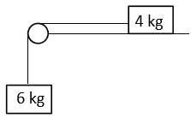
The system is released from rest and both masses move 1·5 metres in their first second of motion.

- Show on separate diagrams the forces acting on each particle.
- Show that the common acceleration of the particles is 3 m s⁻².
- Find the tension in the string.
- Find the value of 𝜇.

(b)
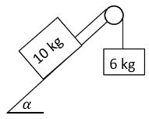
Masses of 10 kg and 6 kg are connected by a taut light inelastic string which passes over a light smooth pulley, as shown in the diagram.
The 10 kg mass lies on a smooth plane inclined at 𝛼 to the horizontal, where $\tan{α=\frac{4}{3}}$.
The 6 kg mass hangs vertically. The system is released from rest.
Find
- the common acceleration of the masses
- the tension in the string.

5.
(a)
Two smooth spheres A and B are sliding towards each other on a smooth horizontal table, with speeds of 3 m s⁻¹ and 1 m s⁻¹, respectively.
Sphere A, of mass 2 kg, collides directly with sphere B, of mass 5 kg.
The coefficient of restitution for the collision is $\frac{2}{5}$ .
Find
- the speeds of A and B immediately after the collision
- the loss of kinetic energy due to the collision
- the magnitude of the impulse imparted to B due to the collision.

(b)
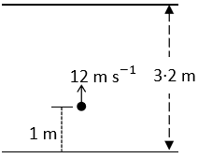
A ball is fired vertically upward in a room with a smooth horizontal floor and a smooth horizontal ceiling. The height of the room is 3·2 metres.
The ball is fired upwards at a speed of 12 m s⁻¹ from a height of 1 metre above the floor.

The coefficient of restitution for all collisions between the ball and the ceiling and between the ball and the floor is $\frac{3}{5}$.
- Find the speed of the ball immediately after striking the ceiling.
- Investigate whether the ball strikes the ceiling again after rebounding from the floor.

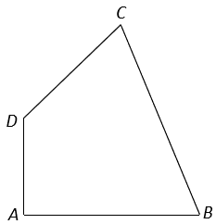
6.
(a)
Particles of weight 4 N, 10 N, p N, and 7 N are placed at the points (3, 8), (p, −6), (4, q), and (p, p) respectively. The co-ordinates of the centre of gravity of the system are (1·5, q).
Find
- the value of p
- the value of q.

(b)
A uniform quadrilateral lamina has vertices A, B, C and D.
The co-ordinates of the points are A(0, 0), B(15, 0), C(9, 12) and D(0, 6).
Find the co-ordinates of the centre of gravity of the lamina.

7
(a)
A uniform beam, [AB], lies horizontally and in equilibrium on supports at points C and D of the beam, as shown in the diagram.

The mass of the beam is 12 kg and the length of the beam is 70 cm. |AC| = |CD| = 20 cm.
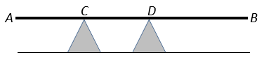
- Find the reaction forces at C and D.
- A mass of m kg is now placed at B. This causes the beam to be on the point of lifting off the support at C. Find the value of m.

(b)
A uniform ladder, of weight 180 N, rests on rough horizontal ground and leans against a smooth vertical wall.
The length of the ladder is 6 m. The ladder makes an angle 𝜃 with the ground, where $\tan{θ=\frac{24}{7}}$ .
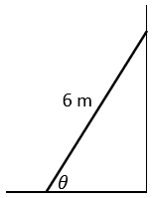
The ladder is in equilibrium and is on the point of slipping.
Find the coefficient of friction between the ladder and the ground.

8
(a)
A particle describes a horizontal circle of radius 0·8 metres with uniform angular velocity 𝜔 radians per second.
The mass of the particle is 0·4 kg. The particle completes 12 revolutions every minute.
Find
- the value of 𝜔
- the speed of the particle
- the acceleration of the particle
- the centripetal force on the particle.

(b)
A smooth particle of mass 0·5 kg is attached by a light inelastic string to a fixed point P.
The particle describes a horizontal circle, of radius 0·2 m, on the smooth surface of a horizontal table.
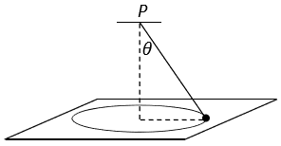
The centre of the circle is vertically below P.
The string makes an angle θ with the vertical, where $\tan{θ=\frac{4}{3}}$ .
The speed of the particle is 1 m s⁻¹.
Find
- the tension in the string
- the reaction force between the particle and the table.

9.
(a)
A solid rectangular block is used as a floating platform.
It has length 6 m, width 5 m and height 2 m.
The platform floats at rest in water with its upper surface (6 m by 5 m) horizontal.
80% of the platform lies below the surface of the water.

Find
the weight of the platform
the mass of the platform in tonnes.
[Density of water = 1000 kg m⁻³]

(b)
A solid sphere has radius 12 cm.
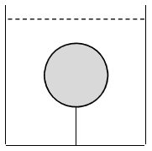
The relative density of the sphere is 0·7 and it is completely immersed in a liquid of relative density 1·5.

The sphere is held at rest by a light inelastic vertical string which is attached to the base of the tank.
Find the tension in the string.

